KomunitasBunda Global Innovative Trade Platform
Comprehensive Final Plan (including Business Valuation Assessment)
Connecting Indonesia and China, reaching the world
Project name: KomunitasBunda Global Innovative Trade Platform
Website: https://komunitasbunda.com
Legal entity: PT. MEGA JAYA TAMBANG (NIB 1503240378135)
Round: Pre-A / Strategic
Amount: not preset; proposed by the investor based on mutual agreement and strategic synergy — open to negotiation
Valuation & terms: proposed by the investor; agreed by both parties on the basis of resource synergy
Date: September 2026
Contact: SiDong Wu — sidongw@Gmail.com

I. Executive Summary
KomunitasBunda is an innovative digital trade platform connecting Indonesia and China and reaching the world. It uses MG.AI as its central computing engine, starts from the two cores of Indonesia and China, then expands through a phased global network to become a key node of South–South digital trade.
Early progress is running smoothly and market response is positive: twelve core technologies are live, the payment and compliance system is connected, early member growth and transaction activity exceed expectations, B2B supply-chain cooperation is expanding quickly, and six high-value products have passed the conversion testing stage. This is not a start-from-zero stage; it is a stage of already running, needing acceleration and reinforcement.
The platform operates the model of an asset package plus a global localised launch price: CNY 100 in China, Rp100.000 in Indonesia, USD/EUR 100 in North America and Europe. This is not a loss-making sale; it hands the one-time sales profit to members and communities in exchange for long-term network income, community trust and capital appreciation. Share the results and the results are already in sight.
The platform gives members not only a platform but also the conversion results of six high-value products, so that 500 million people at the credit edge and students entering work or entrepreneurship every year have a realisable path to success: identity, tools, products, income, credit accumulation and a global network.
In parallel the platform plans 400 operational offices across Indonesia, a province–city–county–community/campus agency system in China, and a country–region–city–community agency system worldwide, ultimately forming one community economy network of Five Flows United: people, money, goods, information and awareness.
In the age of artificial intelligence — when a factory may be left with only its owner and robots — this network positions KomunitasBunda as infrastructure for distributed employment, community entrepreneurship and cross-border trade.

II. Market Opportunity: A Historic Window for Indonesia–China Digital Trade
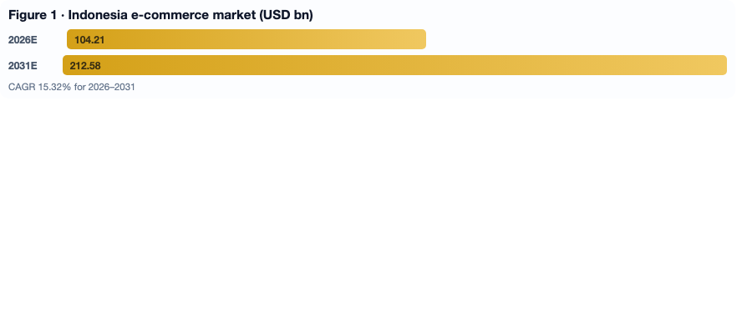
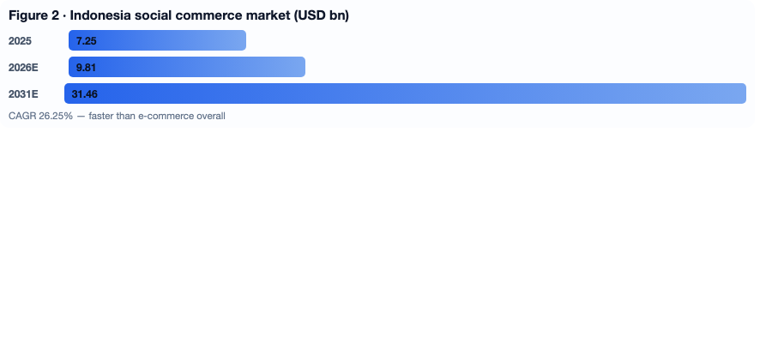
Indonesia is the largest digital economy in Southeast Asia. Its e-commerce market keeps growing at double digits while social commerce and video commerce are exploding. Indonesian consumers rely heavily on community trust, influencer recommendations and content — a strong fit with the membership, community and decentralised warehousing model of KomunitasBunda.
At the same time, local currency settlement cooperation between Indonesia and China is accelerating: direct RMB–IDR settlement, cross-border QR payment interconnection and various policy incentives are being released. KomunitasBunda supports direct settlement in RMB and Rupiah, with the licensed Indonesian gateway Xendit as the clearing institution, funds moving in and out within seconds, directly solving the problem of cross-border fund holding.
- Indonesia e-commerce market: about USD 104.21 billion in 2026, CAGR 15.32% for 2026–2031, reaching USD 212.58 billion in 2031.
- Indonesia social commerce: USD 7.25 billion in 2025, an estimated USD 9.81 billion in 2026 and USD 31.46 billion in 2031, CAGR 26.25%.
- 64 million Indonesian MSMEs absorb most employment, while about 59% of workers remain in the informal economy — digitisation is the incremental gain.
- Only about 18% of Indonesians have basic digital skills, making offline community touchpoints a necessity rather than an option.
This window will not stay open forever. Those who enter early gain institutional advantages that latecomers find hard to replicate.

III. Early Progress and Market Validation

1. Technology infrastructure fully ready
Instant three-language translation, AI help desk, GGAB point ledger, OBTN data dashboard and twelve core technologies are live. The platform has complete capabilities for cross-border transactions, member management, smart recommendation, data visualisation and multilingual service.

2. Payment and compliance connected
The platform is connected to the licensed Indonesian payment gateway Xendit, which holds a Bank Indonesia payment licence and PCI DSS Level 1 certification. Automatic PPN withholding is implemented and sample tax invoices are published — transparent, compliant and building a firewall for capital.

3. Positive early market response
Member registration keeps rising, especially among mompreneurs; cross-border transaction frequency grows steadily; use of direct dual-currency settlement keeps increasing; retention and activity are at industry-leading levels; cooperation intent exists with several Chinese suppliers and Indonesian distributors; six high-value products have entered conversion testing.

4. Verified team execution
The core team has deep industry experience and local operating capability in both Indonesia and China. The smoothness of early work proves its strategic and execution ability.

IV. Core Engine: Asset Package + Six High-Value Products + Global Launch Price

4.1 What the asset package is
The asset package given to members is not merchandise but a set of community entrepreneurship infrastructure: independent launch rights and self-pricing rights; sales rights for designated goods and warehouse profit-sharing rights; full use of digital tools such as instant three-language translation, AI help desk and the GGAB point ledger; global business development rights and decentralised warehouse profit-sharing; and promotion rights plus conversion results of six high-value products.

4.2 Why this price level
The price is calculated precisely: enough to cover the technology, compliance and clearing cost the platform provides per member, yet low enough for mompreneurs, MSMEs, young entrepreneurs and students in Indonesian communities to afford.
The practice of the Indonesian social commerce platform Evermos validates the model: 71% of its resellers are women and one third rely on it as their main income source; resellers spend about 3 hours a day for around USD 43 monthly income, with top performers reaching USD 191 — comparable to the Indonesian minimum wage. KomunitasBunda follows this proven path and adds cross-border trade, dual-currency settlement and six high-value products.

4.3 Global localised launch price
Not foreign-exchange arbitrage and not arbitrary pricing, but an actively designed global local price mechanism based on purchasing power parity, channel cost, compliance tax, community incentives and strategic penetration.
- China CNY 100: the standard anchor of the supply chain, covering direct supply-chain purchase, quality control, domestic fulfilment, platform service, supplier payment guarantee and basic compliance; targeting fast access and scale rather than large margin.
- Indonesia Rp100.000: the community entrepreneurship entry, reset against local purchasing power, consumer psychology and community income; affordable and psychologically acceptable to lower-income groups.
- North America and Europe USD/EUR 100: the global brand anchor, keeping the psychological figure of 100 with currency localisation despite higher compliance, tax, payment, logistics and service costs in advanced markets.
Why so low? Because the platform converts advertising spend, channel fees, intermediary margins and the heavy warehousing assets of traditional e-commerce into income for members and communities. Direct purchase from the Chinese supply chain removes intermediaries; decentralised warehousing frees the platform from heavy assets; dual-currency settlement via Xendit moves funds in seconds; automatic PPN and compliance systems cut grey costs; members promote themselves so acquisition cost is far lower; community incentives are already designed into the launch price.
Low price is not low profit — it is low acquisition cost, high network effect and high user lifetime value. Every active asset package adds one consumer, one promoter, one warehouse node and one cross-border trade connection.

4.4 Profit-sharing mechanism: members, community, government and investors win together
- Members: promotion commission and team incentives; decentralised warehouse profit sharing; GGAB point allocation; cross-border B2B order commission; conversion results of six high-value products; independent launch, pricing and global development rights.
- Community: offline point profit sharing and training income; local jobs and business opportunities; improved digital literacy; accumulation of community trust capital.
- Government: automatic PPN broadening the tax base; published tax evidence making transactions auditable; direct RMB–IDR settlement supporting the local currency strategy; formalisation of the informal economy; support for MSMEs, the women economy and a green digital ecosystem.
- Investors: early equity appreciation and capital exit dividends; global network node positions; compounding data asset returns; policy synergy channels; participation rights in South–South digital trade rules.
In short: the platform gives short-term sales profit to members and communities, and keeps long-term network value for investors and the ecosystem.

4.5 Six high-value products: not only a platform, but goods that earn
Many platforms give tools but no goods, dreams but no income. KomunitasBunda is different. The six selected products feature high margin, high repurchase, high conversion, cross-border fit, controlled supply chain and visible results — ammunition for member success and a cash-flow engine for investor income. Members do not start empty-handed.

4.6 Making 500 million people at the credit edge succeed
Around 500 million people worldwide sit at the credit edge: without traditional bank credit records, excluded from the financial system and mainstream trade. They have working ability, social networks and entrepreneurial desire, but lack identity, tools, products, credit and an entry point. KomunitasBunda offers them a realisable path, not charity: a low entry price; a complete tool set; six high-value products; decentralised warehousing turning consumers into operators; transaction and contribution data recorded in the GGAB ledger and OBTN dashboard as the basis for future compliant credit services; community offline points for those who cannot use an app; and dual-currency settlement so they are never held hostage by fund holding.

4.7 Making students succeed while studying
Every year China, Indonesia and the world produce large numbers of graduates who lack experience, capital, supply chain, customers and credit, but have time, learning ability, social networks and entrepreneurial energy. KomunitasBunda gives them a path of earning while learning and growing while earning: no experience needed to start; no need to select products, stock inventory or build supply chains; independent launch and pricing rights to build their own teams and nodes; real cross-border trade experience; ongoing income; and stronger employability in the job market.

V. Three Promotion Channels: From Individual to Community to Cross-border
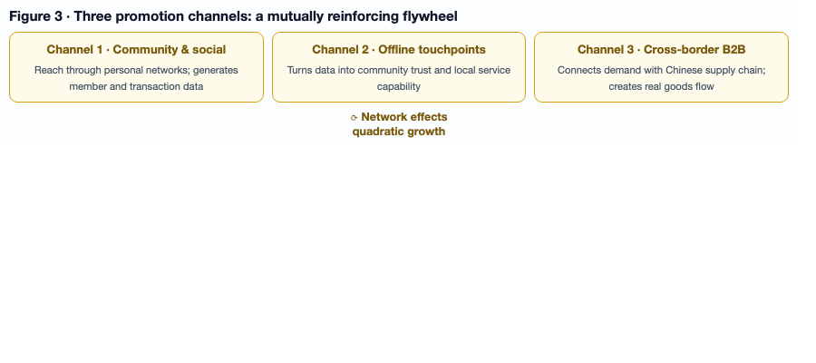

Channel one: community and social network promotion
Members promote the asset package and six products through WhatsApp, Instagram, TikTok and Facebook to their personal networks, supported by three-language translation, AI content suggestions and GGAB point incentives. Economically this replicates the proven Indonesian social commerce growth curve; the government-linked Emak-Emak Matic programme with Shopee trained 2,500 housewives and MSME actors with sales rising up to 3 times and affiliate commissions up to 8 times. KomunitasBunda upgrades this from domestic e-commerce to Indonesia–China cross-border trade with six high-value products, so transaction value and margin room are far larger. Socially, the core groups are Indonesian mompreneurs, people at the credit edge and students.

Channel two: offline entities and community touchpoints
Offline touchpoints in Indonesian communities — community stores, cooperatives, support spaces near places of worship, or members homes — serve as nodes for display, explanation and activation. Economically this closes the digital gap: with only 18% of Indonesians holding basic digital skills, offline points let those who cannot use an app still become members and operators, in line with the government-driven digitisation of village cooperatives. Socially, each point is a micro community economy centre strengthening trust and resilience.

Channel three: cross-border B2B and supply chain promotion
Through the network of Chinese suppliers and Indonesian distributors, the asset package and six products become a supply-chain entry. Chinese suppliers gain distributed sales channels in Indonesia; Indonesian distributors gain direct supply from China. Economically this connects directly with local currency settlement incentives: RMB and Rupiah settle directly, Xendit clears, funds move in seconds, Chinese suppliers are paid faster with lower exchange-rate risk, and Indonesian distributors get lower purchase cost and flexible stock. Socially, Indonesian MSMEs connect directly to the Chinese supply chain, bypassing intermediaries; Indonesian digital economy experience shows 70% of MSMEs entering the digital ecosystem saw income rise by up to 30%, with marketing costs reduced by up to 42.68%.

Synergy of the three channels
Community channels generate member and transaction data; offline points turn data into community trust and local service capability; cross-border B2B connects community demand with the Chinese supply chain, producing real goods flow and dual-currency settlement. Every new member is simultaneously a consumer, a promoter and a cross-border trade node. Network value grows exponentially as nodes increase.

VI. Global Agent Network: 400 Indonesian Offices + China and Global Agents, Five Flows United

6.1 Indonesia: 400 operational offices, ground network first
Planned across major islands, cities, regencies and grassroots communities, these are not traditional branch offices but hubs for local relationship coordination, community service, training, logistics consolidation and cross-border trade service. Each office handles: coordination with local government, cooperatives and community organisations; member registration, training, activation and after-sales; local display, experience and promotion of the six products; offline logistics consolidation and last-mile cooperation; local connection of cross-border B2B suppliers and distributors; mentoring for women entrepreneurs, students and people at the credit edge; tax compliance, KYC/AML and local regulator communication.

6.2 China: province – city – county – community/campus agency system
China is the source of supply chain, the B2B resource pool and an important market for entrepreneurship and student work. The same systems, tools, ledgers and compliance standards as the Indonesian offices are applied, adapted to Chinese administrative divisions and market structure: provincial operation centres handle regional supply-chain integration, government and trade-association relations and large B2B clients; city-level service providers handle local member training, six-product promotion, logistics coordination and channel management; county, community and campus agents handle community promotion, student entrepreneurship and employment, offline point operation and member service; cross-border B2B agents connect Chinese suppliers, industrial clusters and brands, shipping goods to Indonesia and the global network.

6.3 Global: country – region – city – community agency system
Key regions: North America and Europe with the USD/EUR 100 launch price and localised compliance, tax, payment, logistics and customer service; Southeast Asia with Indonesia as one core reaching the Philippines, Vietnam, Thailand and Malaysia; the Middle East, Latin America and Africa following South–South digital trade logic, exporting the low-threshold entrepreneurship model and six high-value products; and global campus agents connecting students across countries.

6.4 Unified agent functions
Whether in Indonesia, China or globally, agents perform the same functions: connecting government, cooperatives, trade associations, community organisations and campuses; member registration, training, activation, after-sales and community operation; display, experience, conversion and repurchase of the six products; logistics consolidation, delivery, last mile and return support; cross-border B2B supplier connection, distributor matching and order coordination; KYC/AML, automatic PPN and tax invoice publication; and returning transaction, promotion and supply-chain data to the platform.

6.5 Five Flows United, global version
- Flow of people: members, promoters, students, community entrepreneurs, suppliers and distributors moving between nodes.
- Flow of money: RMB, Rupiah and multiple currencies with licensed clearing, funds in and out within seconds.
- Flow of goods: Chinese supply-chain goods entering Indonesia and the world through cross-border routes, distributed via agent nodes.
- Flow of information: three-language translation, AI help desk and the OBTN dashboard making information flow transparently.
- Flow of awareness: digital literacy, entrepreneurial awareness, tax compliance awareness and cross-border trade insight spreading and settling in communities.
Five Flows United means the platform is no longer merely a website but community economy infrastructure covering Indonesia, China and the world.

6.6 Agent income and investor returns
Agents are revenue centres, not cost centres. Income sources include regional warehouse profit sharing, promotion commission and team incentives, conversion results of the six products, cross-border B2B order commission, training, logistics and local service income, GGAB point allocation and appreciation of early agency rights. For investors: agents form a hard-to-replicate offline network barrier; Five Flows United upgrades the platform from a website to infrastructure; in the AI era distributed entrepreneurship and community services become necessities; locking in the 400 Indonesian offices, the China agency system and the global network early equals locking in the entrance to the global community economy.

6.7 The AI era: factories left with owners and robots, platforms as the way out
The AI era is accelerating. Traditional production-line jobs are replaced by automation and many workers need new ways to work and to build businesses. This is not a distant future but a reality in progress. KomunitasBunda sits exactly on this trend: low threshold, distributed, productised, tool-enabled, cross-border and credit-accumulating. AI replaces repetitive work and creates distributed entrepreneurship and community services; KomunitasBunda does not fight AI, it uses AI — MG.AI, AI tools and automatic clearing let ordinary people join global trade at very low cost.

VII. Business Valuation

7.1 Valuation methodology
The value of KomunitasBunda cannot be measured by traditional DCF or a single financial indicator, because its value comes mainly from network effects, community trust capital, policy synergy channels and data assets. We therefore use a comprehensive framework: comparable company method as primary, segmented valuation as support, and network effect premium as adjustment.
- Comparable company method: referencing capital market pricing of e-commerce, social commerce and cross-border trade platforms in Southeast Asia and globally, adjusted for the KomunitasBunda stage.
- Segmented valuation: splitting value into e-commerce business, financial technology (dual-currency clearing), community network (400 offices plus agency systems) and data assets, valued separately then summed.
- Network effect premium: every new member adds a node; connections grow quadratically; transaction opportunities, data value and supply-chain efficiency rise non-linearly — a premium not fully reflected in traditional models, yet the core source of long-term value.

7.2 Market references and valuation anchors
In capital markets, Sea Limited (parent of Shopee) shows e-commerce business valuation around 1.7x forward 12-month EV/Revenue, while comparable platforms average around 2.5x; CICC using a segmented approach assigns PS 2.94x to the Shopee business for 2026, equivalent to about USD 58.389 billion. Globally, Shein is valued at RMB 456 billion, Whatnot at USD 20 billion and ByteDance Fanno at USD 5 billion. These references show that capital market pricing logic for the Southeast Asian digital trade track is clear, and platforms with network effects, cross-border capability and community barriers receive significant premiums.

7.3 Revenue projection and valuation range
Based on the running model, three-year revenue is projected structurally (no specific figures, logic only):
- Layer 1 — membership revenue: conservatively hundreds of thousands of active members in year one at an average global launch price of about CNY 100 / Rp100.000 / USD-EUR 100; with word of mouth and the agency network, year two may reach millions and year three tens of millions.
- Layer 2 — conversion results of six high-value products: high margin and high repurchase give stable recurring cash flow growing linearly with the member base.
- Layer 3 — cross-border B2B commission and supply-chain services: higher margin than pure membership revenue.
- Layer 4 — agent profit sharing and services: regional warehouse sharing, training income and logistics services form diversified cash flow.
Using the comparable company method and referencing the 1.7–2.9x EV/Revenue range of Southeast Asian e-commerce platforms, plus the network effect and community barrier premium of KomunitasBunda, the conservative valuation range may reference the Pre-A funding level of early-stage Southeast Asian digital trade platforms, while the growth range approaches leading regional e-commerce platforms as member scale and transaction data grow. Specific figures are subject to mutual agreement.

7.4 Return logic
Pre-A investors acquire not only equity in a running model but an early ticket to the exponential growth period of network effects. As members move from millions to tens of millions, the 400 Indonesian offices cover the whole country and the global agency network takes shape, platform valuation enters the growth range. The exit path is clear: positioned as a key node of South–South digital trade, moving mid-term towards global listing and a green digital ecosystem; referencing the capitalisation paths of Sea Limited, Shein and Whatnot, KomunitasBunda has the potential for IPO or strategic merger exit in Southeast Asian or global capital markets.

7.5 The unquantifiable part of business value
- Community trust capital lasting more than ten years, not visible in quarterly reports: income, customer relationships and community identity are bound to the platform.
- Exponential network effect returns from 500 million people at the credit edge and millions of students each year.
- Policy synergy strategic returns: alignment with government goals of adding tax revenue, promoting local currency settlement, supporting MSMEs, empowering women, creating jobs and coordinating local relations.
- Structural returns of the AI era: distributed entrepreneurship and community services as necessities.
- Compounding data asset returns: more usage makes data more accurate, more accurate data makes matching more efficient, more efficient matching brings more members — a self-reinforcing flywheel.
These unquantifiable values are what distinguish KomunitasBunda from traditional e-commerce platforms, and the fundamental reason early investors can obtain excess returns.

VIII. Impact for Government
Concrete steps: tax transparency with automatic PPN and published sample tax invoices so every transaction is traceable and auditable; local currency settlement connected to the licensed Xendit clearing, supporting direct RMB–IDR settlement within the Indonesia–China LCT cooperation framework; a KYC/AML system with member identification, transaction monitoring and anti-money-laundering mechanisms; auditable data through the OBTN dashboard and GGAB ledger providing real-time basis for supervisors; 400 operational offices coordinating local relations and helping regional governments, cooperatives and community organisations bring digital trade to the grassroots; synergy with village cooperative digitisation; and a green digital ecosystem promoting low-carbon logistics and sustainable consumption.
Meaning for government: broadening the tax base by bringing informal economy transactions into the taxable area; promoting local currency settlement in line with the national financial cooperation strategy; creating formal jobs; supporting MSMEs and the women economy; social stability by giving income, skills and hope to people at the credit edge and students; and answering the employment challenge of the AI era.

IX. Impact for Community
Concrete steps: a low entry threshold so ordinary families and students can join global trade at controlled cost; six high-value products so there are goods to sell and income to earn; instant three-language translation for barrier-free Indonesia–China communication; AI help desk lowering the operating threshold; GGAB point ledger making contribution measurable and income allocable; independent launch and pricing rights giving real operational autonomy; decentralised warehousing returning growth income to communities; 400 offices and offline points so those who cannot use an app can still participate; and the Five Flows United network unifying people, money, goods, information and awareness into the community.
Meaning for community: consumers become operators; community trust capital accumulates with every office and offline point; digital literacy spreads; diversified income raises resilience; people at the credit edge rise from having no credit record to owning transaction data, income and digital assets; and students run businesses while studying, adding nodes, promoters and cross-border trade talent every year.

X. Unquantifiable Returns
- First: exponential network effect returns — every active asset package is a new network node; connections grow quadratically.
- Second: long-term community trust capital returns — members will not leave for a 2% cheaper alternative.
- Third: policy synergy strategic returns — investors gain not only business returns but policy synergy channels and early compliance advantage.
- Fourth: South–South digital trade node returns — accumulated trade data, clearing experience and supply-chain relations become rule participation rights.
- Fifth: compounding data asset returns — a self-reinforcing flywheel.
- Sixth: incremental returns from 500 million people at the credit edge and students each year — a large additional market never systematically served by traditional e-commerce.
- Seventh: structural returns of the AI era — early investors lock in a seat in the community economy infrastructure of the AI era.

XI. Funding Need and Use of Funds
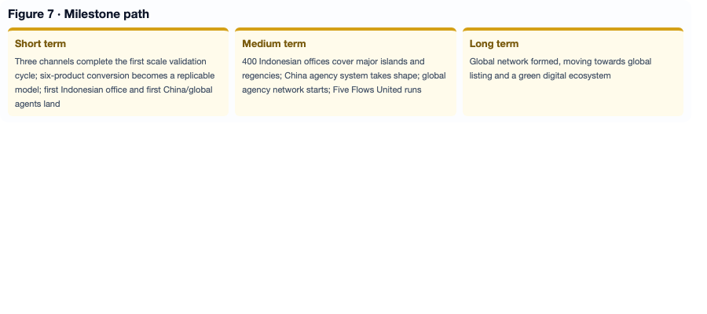
The funding amount is not written in advance; it is proposed by the investor. We do not preset amount, valuation or terms. We value more the government communication capability, community network resources, supply-chain relations, payment compliance experience and global capital channels behind the funds.
Use of funds is to make the running model more stable and solid. Main investments: 400 Indonesian operational offices (site selection nationwide, local teams, training systems, local relationship coordination); the China agency system (province–city–county–community/campus build-out, student entrepreneurship and employment programmes); the global agency network (country–region–city–community agents, multi-currency compliance); community channel scale (AI translation optimisation, content tool development, member incentive design); offline point build-out; cross-border B2B expansion (Chinese supplier network, Indonesian distributor connection, supply-chain financial services); six high-value products (selection, supply-chain guarantee, margin optimisation, conversion testing, brand building); programmes for people at the credit edge and students; compliance and risk management (multi-market licences, tax compliance systems, KYC/AML upgrade); and government and community synergy projects.
Milestones: short term — the three channels complete the first scale validation cycle, six-product conversion results form a replicable model, and the first Indonesian office plus first China and global agents are established; medium term — 400 Indonesian offices cover major islands and regencies/cities, the China agency system takes shape, the global agency network starts, Five Flows United runs and the credit-edge and student programmes scale; long term — the global network is formed, moving towards global listing and a green digital ecosystem.

XII. Why Act Now
- First: the model is already running; investing now is acceleration, not adventure.
- Second: early-node dividends decline with time — the earliest members, offline points, cross-border B2B channels, student and credit-edge nodes, Indonesian offices and China/global agents enjoy the highest income, least competition and strongest policy synergy.
- Third: the policy window does not wait — local currency settlement and cross-border QR interconnection have just launched.
- Fourth: the valuation valley exists only at the start — the amount is proposed by the investor and we are open; when data improves the valuation will not be this price.
- Fifth: results are already in sight, not empty promises.
- Sixth: the AI era brings structural opportunity.
- Seventh: the opportunity cost of not investing is very high — missing the first wave of local currency settlement dividends, the early node positions, the six-product cash flow, the offline network barrier, the low valuation and the last strategic position before IPO.
Suggested action: reach mutual agreement promptly, lock the quota of this round, sign the term sheet, and after funds arrive deploy immediately into the three channels, six products, 400 Indonesian offices, the China agency system, the global agency network and the credit-edge and student programmes.

Annex I. Investment Value and Return (structural illustration)
This annex explains value through structure rather than promises. The platform does not promise fixed returns or return of principal; what follows is a layered revenue structure and scenario illustration based on genuine transactions. Actual results depend on member scale, product conversion and supply-chain maturity.

1. How the four revenue layers stack
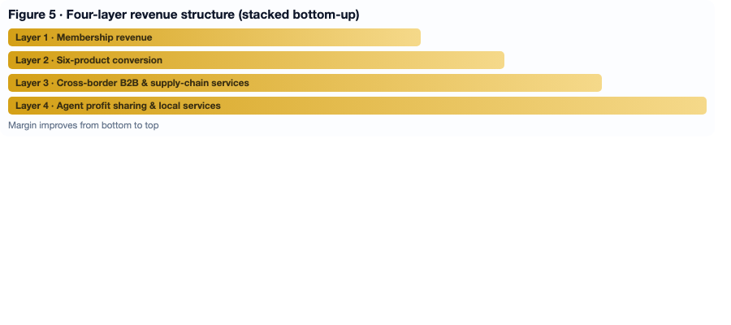
Layer 1 membership revenue is the cash-flow foundation; layer 2 six-product conversion brings high-frequency repurchase; layer 3 cross-border B2B commission and supply-chain services carry the highest margin; layer 4 agent profit sharing and local services turn the network into diversified income. The point of stacking: no single layer can break the whole model.

2. Annual value per member
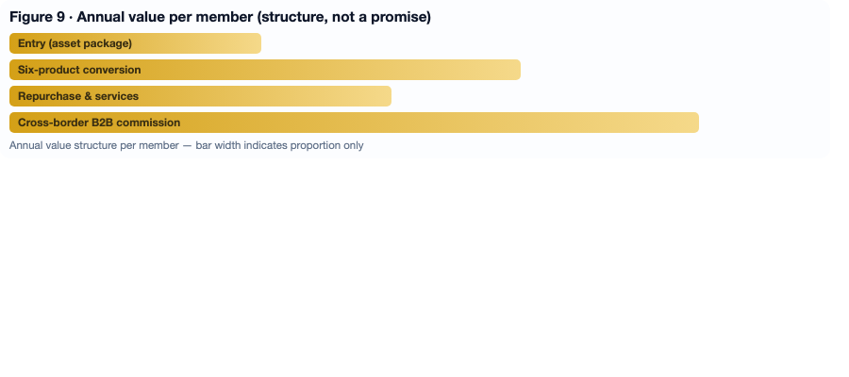
A member is not one-off revenue. Entry (asset package) is only the door; the long-term value lies in six-product conversion and repurchase, local services and cross-border B2B order commission. The longer a member stays, the higher the annual value per member — which is why a low entry threshold works financially: very low acquisition cost in exchange for long, cumulative lifetime value.

3. Return scenarios (illustrative)
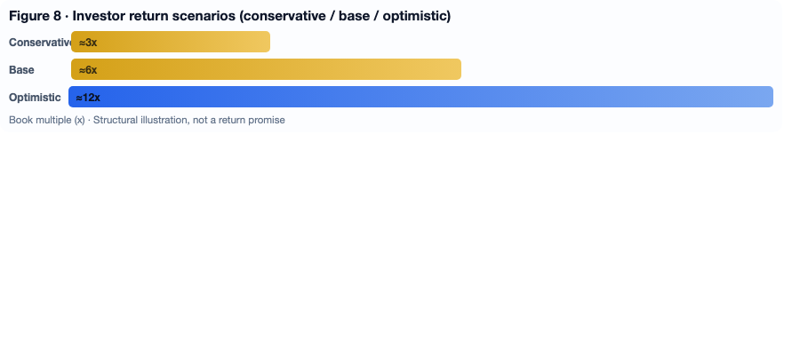
- Conservative: network advances at the current pace; early investor book multiple around 3x.
- Base: the 400 Indonesian offices are more than half deployed and the China agency system takes shape; around 6x.
- Optimistic: the global agency network is formed, six products scale and cross-border clearing volumes rise; around 12x.
All three scenarios share the same premises: genuine transactions, single-level settlement and compliant operations. Scenarios are structural illustrations, not a return promise.

4. Four values beyond revenue
- Community trust capital measured in decades — invisible in quarterly reports, decisive for long-term retention.
- Network effect premium: as nodes grow, connections grow quadratically and value rises non-linearly.
- Data asset compounding: more usage makes data more accurate, and recommendation plus supply-chain matching more efficient — a self-reinforcing flywheel.
- Policy synergy and rule participation: an early position in local currency settlement, tax base expansion, MSME and women economy agendas.

Annex II. First-round funding recommendation (internal draft · negotiation reference)
Externally the position remains: amount and valuation are proposed by the investor and agreed by both parties. This annex is an internal reference range to judge whether an offer is reasonable — it is not an external commitment.

1. Recommended first-round size: USD 1.5m – 3.0m (USD 2.0m recommended)
- Minimum USD 1.5m: about 12–18 months of runway, focused on the first Indonesian offices, six-product supply chain and three-channel validation.
- Recommended USD 2.0m: covers Indonesian office rollout, the China agency system and first global nodes, plus compliance and risk upgrade.
- Full USD 3.0m: acceleration beyond the recommended tier, suited to a strategic investor bringing industrial resources in one tranche.

2. Recommended equity: 10% – 12% (up to 15% for strategic resource partners)
- 10%–12%: reasonable for financial investors and general strategic partners, implying pre-money valuation of about USD 13m – 20m.
- 12%–15%: only when the investor brings clearly deliverable resources (supply chain, payment and clearing channels, government and community relations, traffic), written into the term sheet annex as committed contribution.
- Not above 15%: early over-dilution squeezes the Series A space and team incentives, and weakens founder control over long-term strategy.

3. Suggested structure and terms
- Tranched: 60% at closing, 40% released upon milestones (reducing risk on both sides).
- 1x non-participating liquidation preference; weighted-average anti-dilution.
- One board seat or observer seat; founder control and veto on key matters retained.
- 10% employee option pool reserved pre-money, for core team and regional leaders.
- No fixed-return bet: milestone-based release instead — compliant and sustainable.

4. Allocation of funds
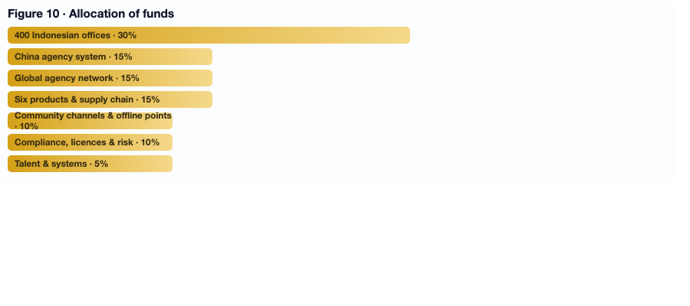
Principle: thicken the two hardest-to-replicate assets first — the ground network and the supply chain — before scaling traffic. Compliance and risk control are survival money and must not be cut.

5. Negotiation guidance
- Ask first: what resources can you bring (supply chain / payment channels / government and community relations / traffic)? Then discuss price.
- When pressured on valuation, trade resources for price: write resource commitments into the term sheet annex, with equity or release conditions adjusted if unmet.
- Tranching is the best protection: exchange milestones for trust, and avoid diluting too much at once.
- Red lines: control, compliance boundary (no return promises), single-level settlement.

XIII. Closing
- The asset package is not a product; it is the entrance to community economy infrastructure.
- The six high-value products are not ordinary goods; they are ammunition for member success and the cash-flow engine of investor income.
- The three promotion channels are not marketing tools; they are a three-layer network effect engine from individual to community to cross-border.
- The 400 Indonesian offices and the China and global agency networks are not branch offices; they are the physical points of the Five Flows United network.
- CNY 100, Rp100.000 and USD/EUR 100 are not merely prices; they are the global localised launch price and the entrance to profit sharing.
The platform turns 500 million people at the credit edge from the excluded into participants in global trade, and lets students each year run businesses while studying, earning while growing. In the AI era — when factories may be left with only owners and robots — the platform becomes a new way out for distributed employment, community entrepreneurship and cross-border trade.
Early progress is smooth and market response is positive. The purpose of this funding round is to make an already running model more stable and solid. The specific amount is proposed by the investor; we are open to negotiation. We invite investors with strategic vision to join us in building South–South digital trade infrastructure and the community economy of the AI era from the beginning. Act now and lock in the early nodes; wait longer and the cost is higher, the quota smaller and the window narrower.
Contact: SiDong Wu — sidongw@Gmail.com — https://komunitasbunda.com
Market data in this plan comes from public research reports and industry statistics for reference only. Specific financial data, operating indicators, materials on the six products and valuation terms can be provided and negotiated by mutual agreement. This plan is not a guarantee of return of principal or fixed yield; investment involves risk, decisions require caution, and specific terms follow the formal agreement signed by both parties.

